Extention Methods:
Collections:
Delegates
Interface
Generics
LINQ

LINQ:

To write a LINQ query, we need the following three things
- Data Source (In-Memory Objects, SQL Server, XML Document, etc)
- Query
- Execution of the Query
Query:
- Initialization (to work with a particular data source)
- Condition (where, filter, sorting condition)
- Selection (single selection, group selection, or joining)

Different Ways to Write a LINQ Query?

Query Syntax
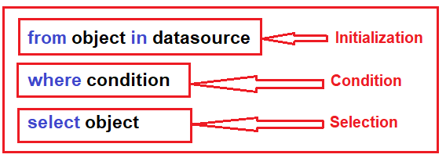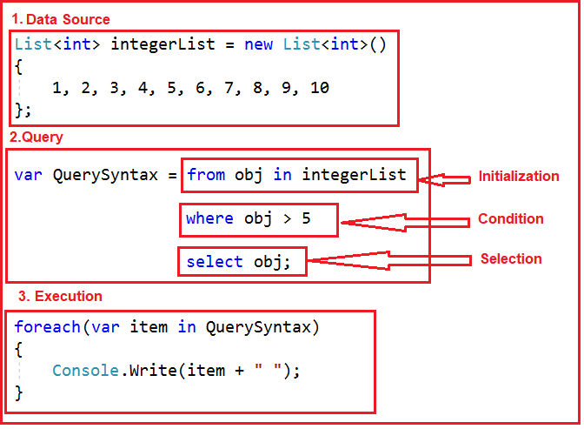

Method Syntax
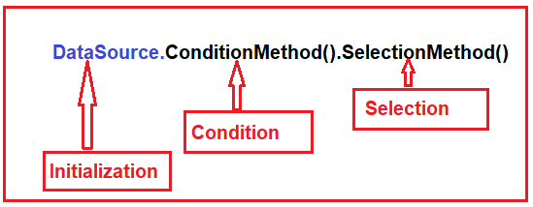
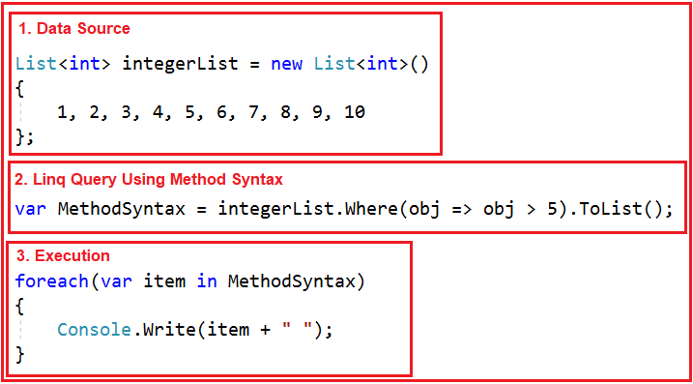

Mixed Syntax (Query + Method)
